The Management of Ellembelle District organized a two-day workshop at Aya community center on the 28th to 29th March 2022 for both Assembly Members, Unit Committees Members. The training was held purposely to equip members on their goals and objectives in the assembly, their DO’s and DON’T’s and also to help revive the operations of Ellembelle area councils. The resource person by name Mr. Anthony Azasoo spoke on the composition of Area councils, functions and meetings that are to be held by the unit and Area councils’ committees. The two-day workshop came to a successful end with a closing remark by District Coordinating Director in the person of Emil Tawiah Atsu (CDFA), he indicated that those area councils without offices should look for some immediately, and those who have too will be furnished to start operation soon.
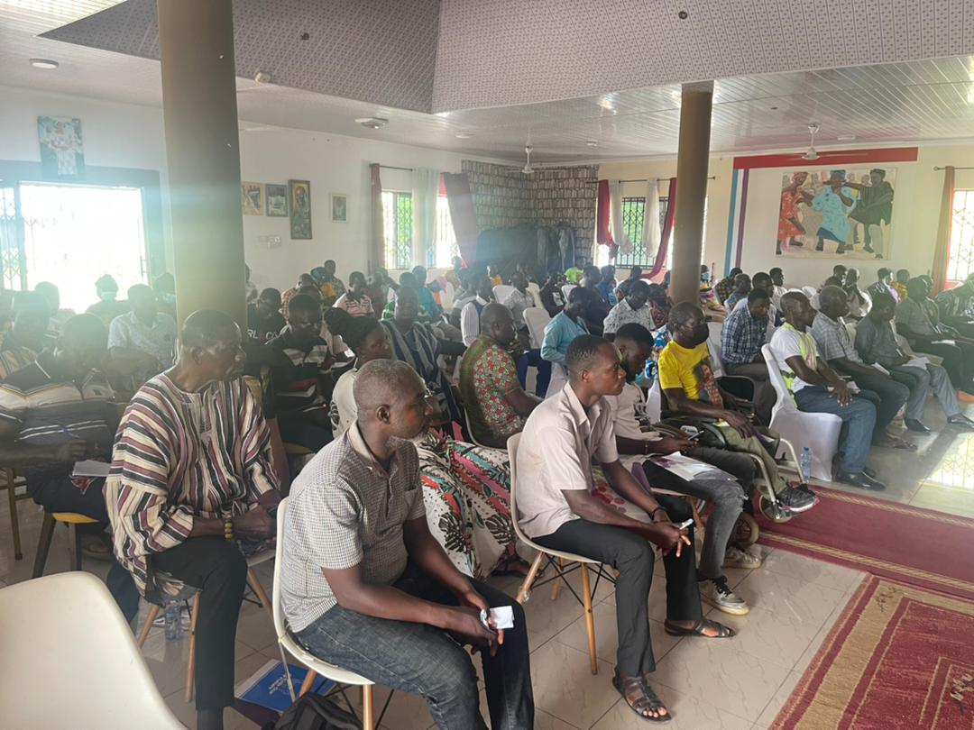

The District Presiding Member, Hon. David Enu on behalf of the Assembly Members and Unit Committee members also thank the Management of the Assembly for the knowledge given them and promised their support to make Ellembelle great


