On the 8th of September,2022 our District were honored with a visit from the Regional Minister in the person of Hon. Kobina Okyere Darko Mensah and some of his subordinates from the Regional Office (Chief Director, Regional budget director, regional planning Director).
The Chief Director spoke about punctuality, how a Civil Servant should be committed to his or her task, being productive at working hours, the way and manner they do their reporting (being it annually, quarterly, etc.) should be done on time and submitted to the Regional Office, when it delays it goes a long way to affect their productivity. Again, he urges them to offer good services to the People of Ellembelle District when citizens need their quota. He went further to caution them about the leakage of documents which is contrary to professionalism.

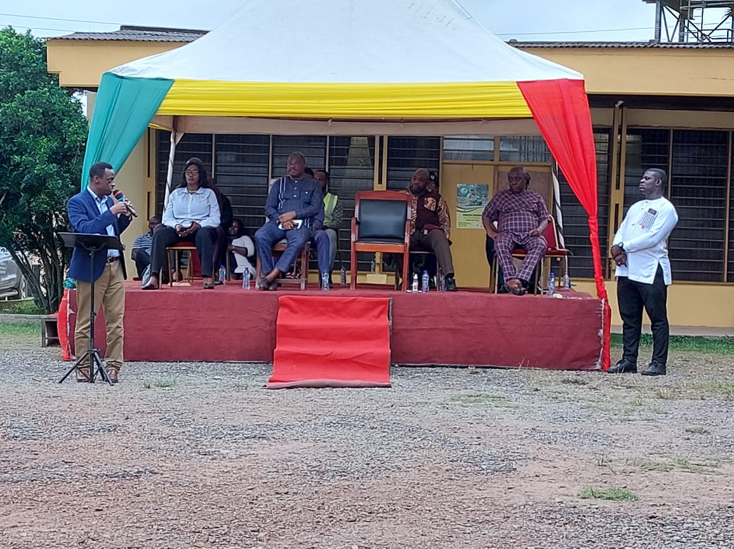

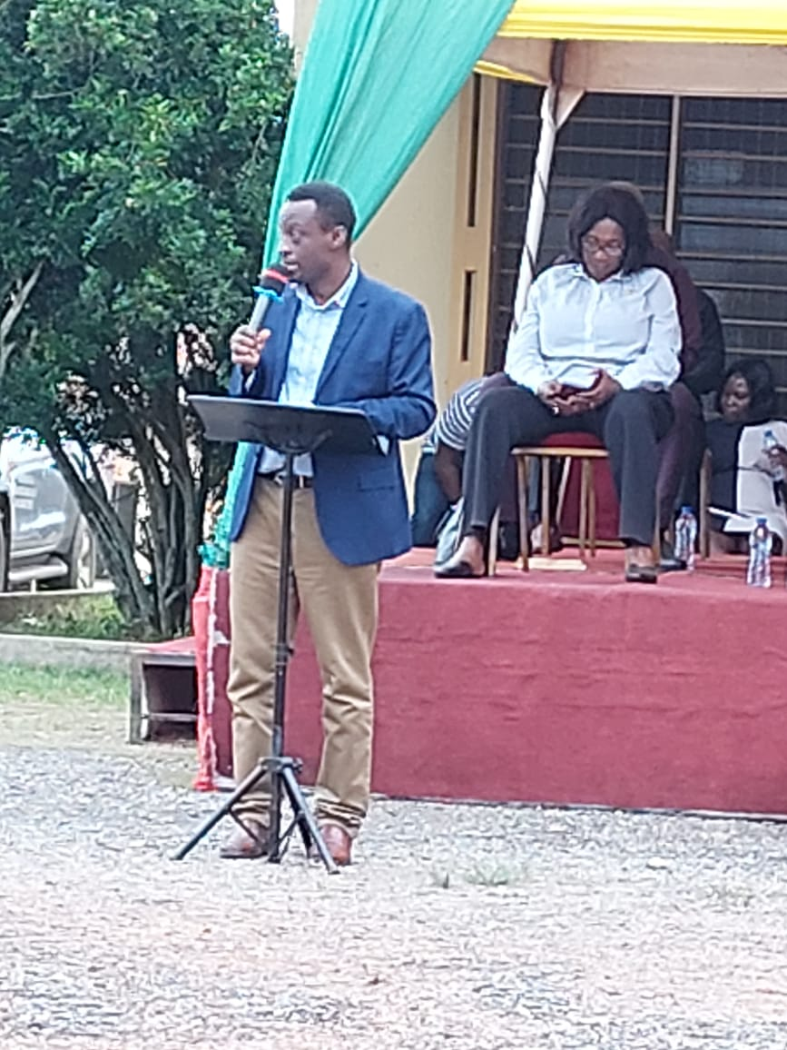
Hon. Kobina Darko expresses how happy he was to be with them and the commended Ellembelle District ranked as the 6th richest district in the Western Region. He cautioned them to do away with procrastination of documents that are to be done for some days but takes month or more to be completed. He went ahead to talked about how the Assembly could generate more revenue to the district. He furthered that; there is a decision to make Western Region the No.1 tourist destination in Ghana. He praised the District Assembly that, for him, his second-best place to be is the Maaha beach Resort situated in Ellembelle district and this will attract People to the other tourist site hopefully and that mechanisms should be put in place for this course.
He also pointed it out that, His team has come out with a software application that allows people who litter the environment to be punished with a fine. This application software will be opened to the public but not only Ellembelle as a district.

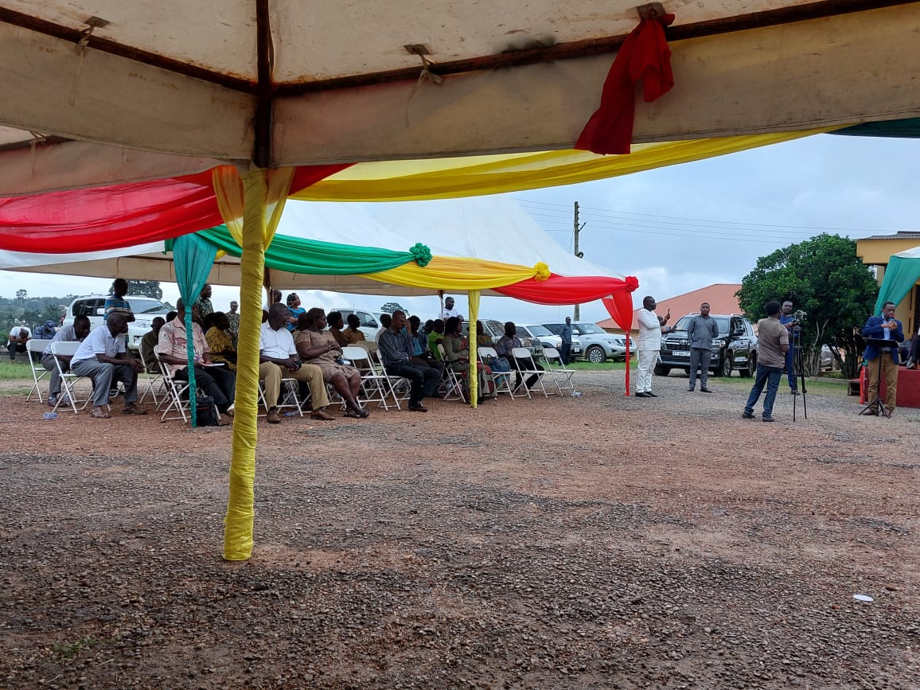

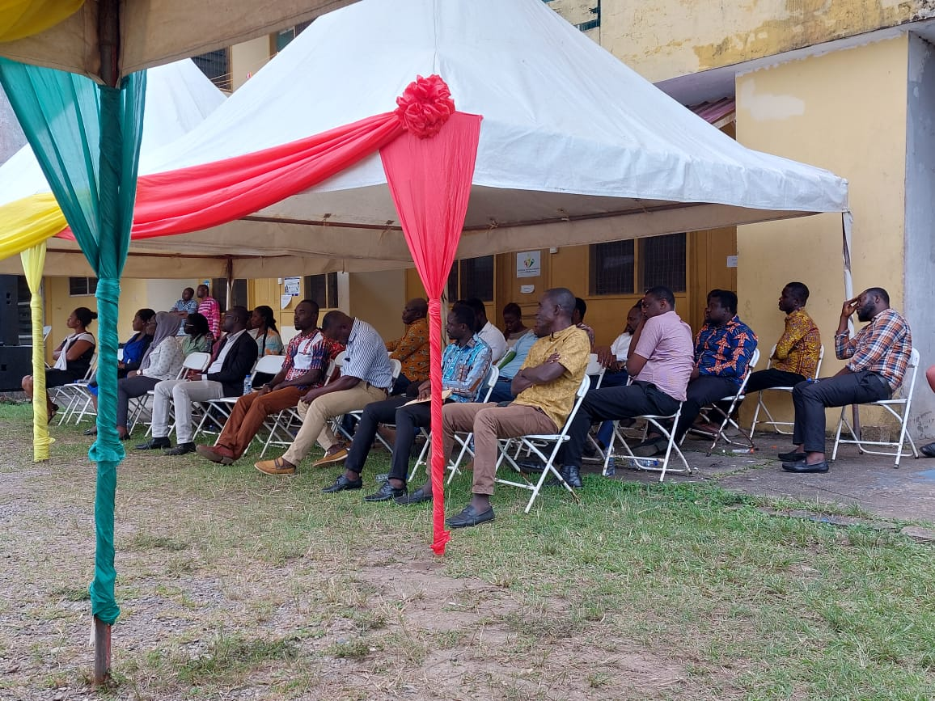

He further said, one of the biggest avenues for revenue generation is for the staffs to know what is right and the Knowledge acquired to implore and also let their impact be felt in the Assembly before they are transferred or retired.

