WORKING VISIT TO ELLEMBELLE DISTRICT ASSEMBLY
The head of service in the person of Ing. Dr. Nana Ato Arthur accompanied by the Chief Director of Service (Mr. James Oppong Mensah) and the Regional Coordinating Director for WRCC (Mr. Fredrick Agyemang) visited the Staffs of Ellembelle District Assembly on the 1st of September ,2022 at 11:00am at the forecourt of Kwame Nkrumah Motel. The purpose of their coming was to deepen the administration of the decentralization system in this institution. Hon. Kwasi Bonzoh addressed and welcome them to the district. In his welcome address he spoke about some achievements the district has made in the past years of his tenure and some challenges they are facing as a district. He called on the Head of Service to help them achieve it especially with the contract and the completion of the new Assembly Complex. He also pleaded with the Head of Service to mechanized some of his IGF Staff because of their hard work and dedication to the Office.
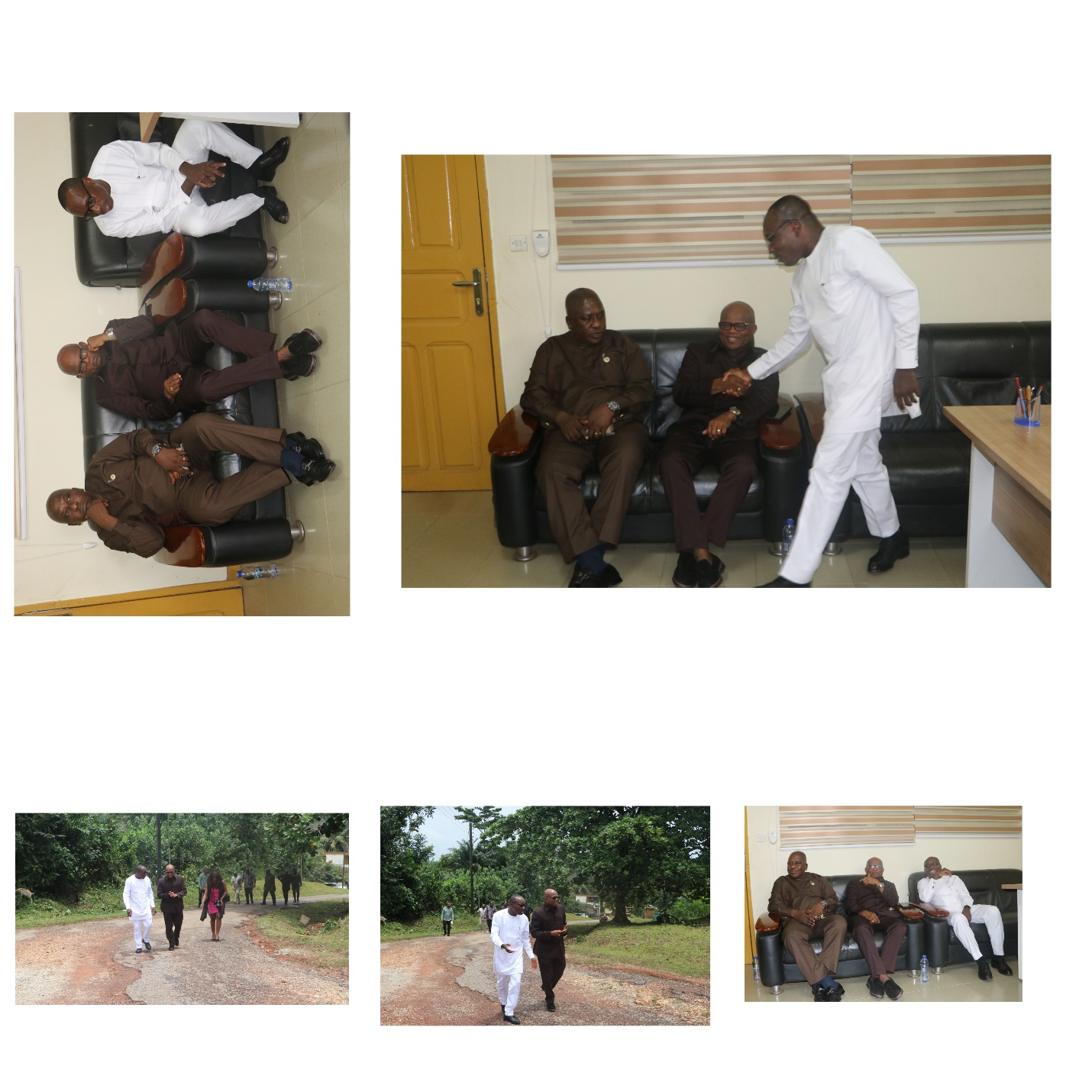
The Chief Director of Service also spoke about the purpose of their visit in detailed; to know where their staffs are, how they are coping with work and under their directorates and their needs as a district.
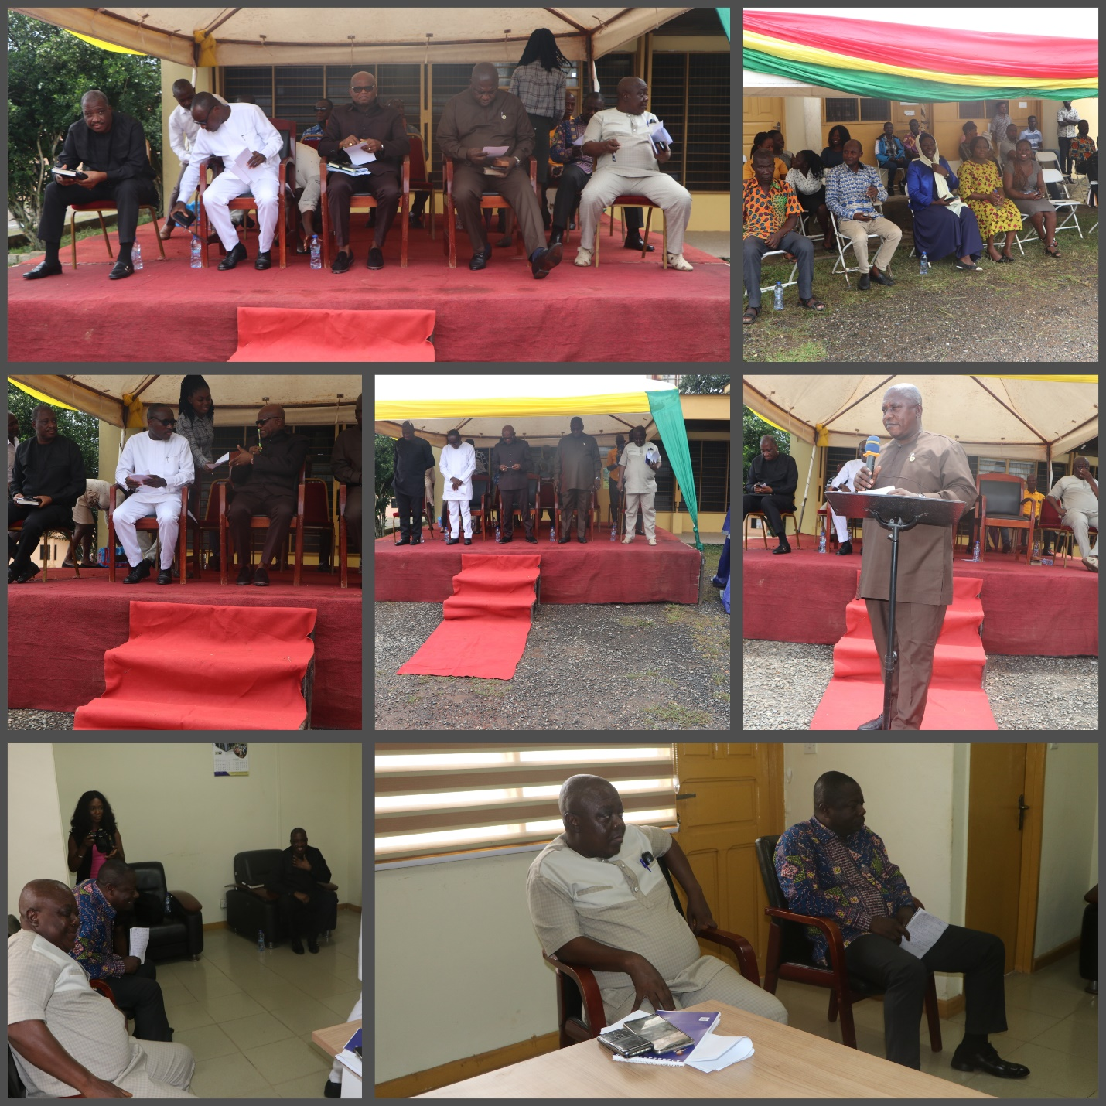

The head of Service also spoke about the good work done during the Covid-19 and he expressed his profound gratitude to the staff of Ellembelle district Assembly for the work done so far. He encouraged the Staff to improve on their punctuality to work, there should be a cordial relationship between Departments, Units and Staffs. He emphasized on the fact that the Staffs were brought here for the development of the district and not for their own personal interest, so whatever they do, the district should be their priority.
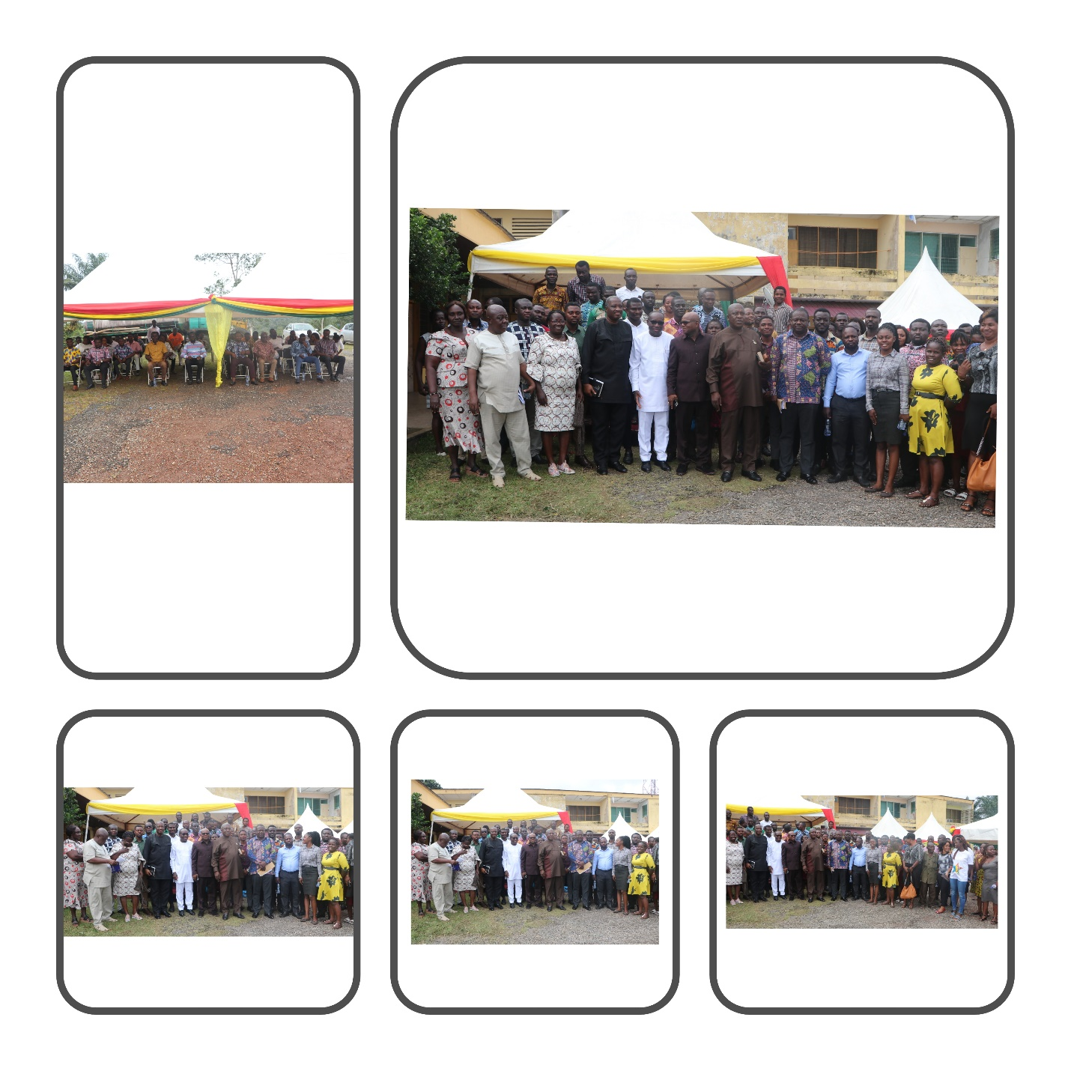

Questions, answers and suggestions were made by some Staffs to improve the working environment or condition for the developments of the Ellembelle District.

