ELLEMBELLE DISTRICT ASSEMBLY
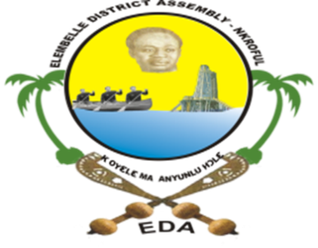
In case of reply, the Ref. P. O. Box 34
number and date of this NKROFUL
letter should be quoted. WESTERN REGION
GHANA
GPS: WE-0002-4838

Email Address: ellembelledistrict@gmail.com
Website : eda.gov.gh
REPUBLIC OF GHANA

Tel: 0577710081/0577710084
S/N | PROJECT FOR 2023 | CONTRACTOR/SUPPLIER | CONTRACT SUM
1 | Construction of 1 no. 10 Seater Water Closet with Mechanized Borehole at Kikam | 17 KATONA COMPANY LTD | GH 361,941.69
2 | Construction of 1 no. 10 Seater Water Closet with Mechanized Borehole at Esiama | ZONG-YIN COMPANY LTD | GH 360,905.51
3 | Construction of 1 no. 10 Seater Water Closet with Mechanized Borehole at Kamgbunli | ABERA CONSTRUCTION LTD | GH 365,953.54
4 | Construction of 1 no. 10 Seater Water Closet with Mechanized Borehole at Aiyinase | JACOA CONSTRUCTION LTD | GH 361,763.50
5 | Construction of 1 no. 10 Seater Water Closet with Mechanized Borehole Nvuma | SUNNYDALE LTD | GH 364,134.56
6 | Construction of 1 no. 10 Seater Water Closet with Mechanized Borehole Edwakpole | ATTANS ENTERPRISE LTD | GH 363,741.10
7 | Construction of 1 no. 3 Unit Market Shed with 2 no. Urinals at Nkroful | SEKAMET INFINITY LTD | GH 458,334.45
8 | Construction of 1 no. 1 Unit Modern Lockable Fish Market with 3 Hand Washing Facilities, Terrazzo floor, ceiling, and 4-seater Water Closet toilet at Aiyinase | SEKAMET INFINITY LTD | GH 657,519.39
9 | Construction of 1 no. 6 Seater Water Closet with Mechanized Borehole at Basake | PROJECKT 1 LTD | GH 341,769.14
10 | Rehabilitation of DCD`s Residence at Nkroful | KYEKAWA LTD | GH 420,289.66
11 | Manufacturing and Supply of 500 Desk and 100 Teachers Tables and Chairs | SDSD LTD | GH 380,000.00
12 | Construction of 1 no. 6 Seater Water Closet with Mechanized Borehole at Asanda | ATTANS ENTERPRISE | GH 342,438.64
13 | Supply of 4*4 double cabin Pick-Up vehicle | 17 KATONA COMPANY LTD | GH 879, 807.00
14 | Supply of LED streetlight | SUNNYDALE LTD | GH 225,001.00
15 | Supply of Uniforms | SUNNYDALE LTD | GH 310,000.00
16 | Supply of furniture | SDSD LTD | GH 1,08,000.00
17 | Supply of Construction Materials for Self Help Projects. | SDSD LTD | GH 768,000.00

