COMPLETED PROJECTS AND THEIR LOCATIONS FOR THE YEAR 2021 - 2022

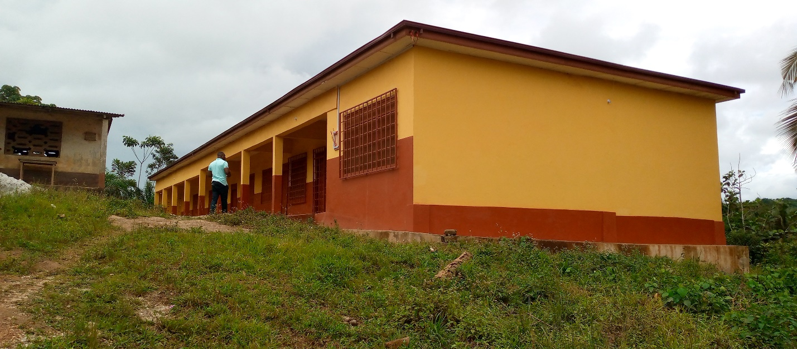

PROJECT: CONSTRUCTION OF 3 UNIT CLASROOM BLOCK WITH OFFICE AND STORE,
STAFF COMMON ROOM AND ICT CENTER
LOCATION: NVENLENSOLO
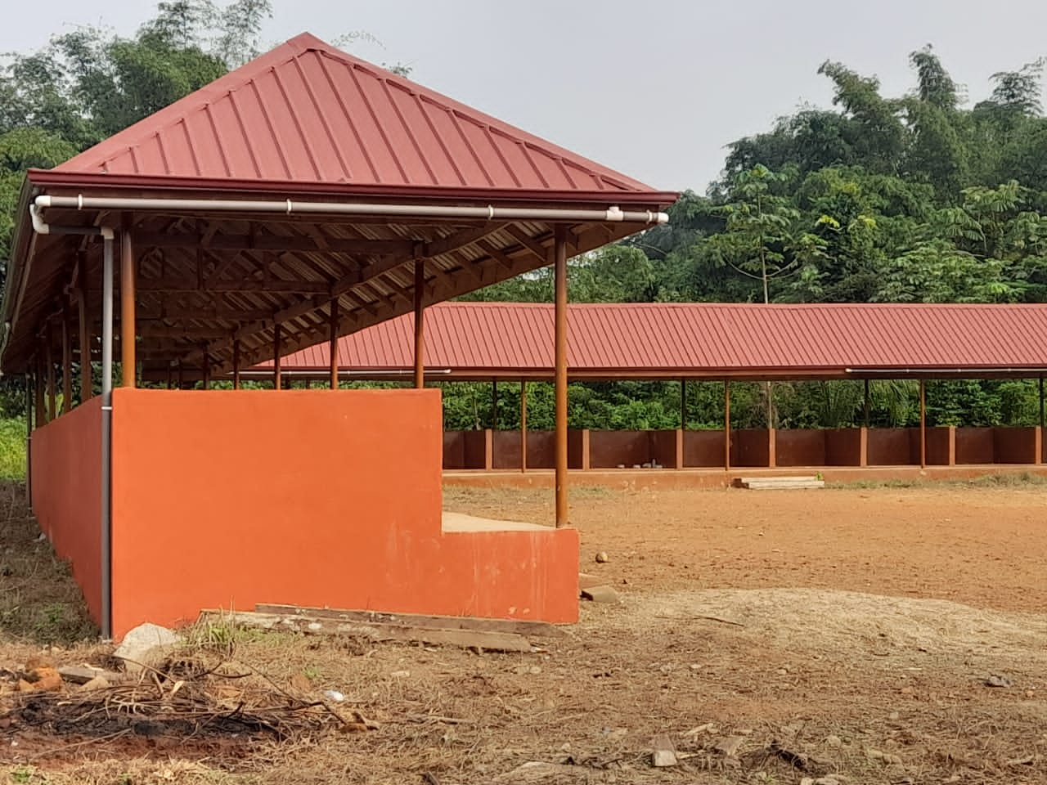

PROJECT: CONSTRUCTION OF 3NO. MARKET SHED
LOCATION: ADUBRIM

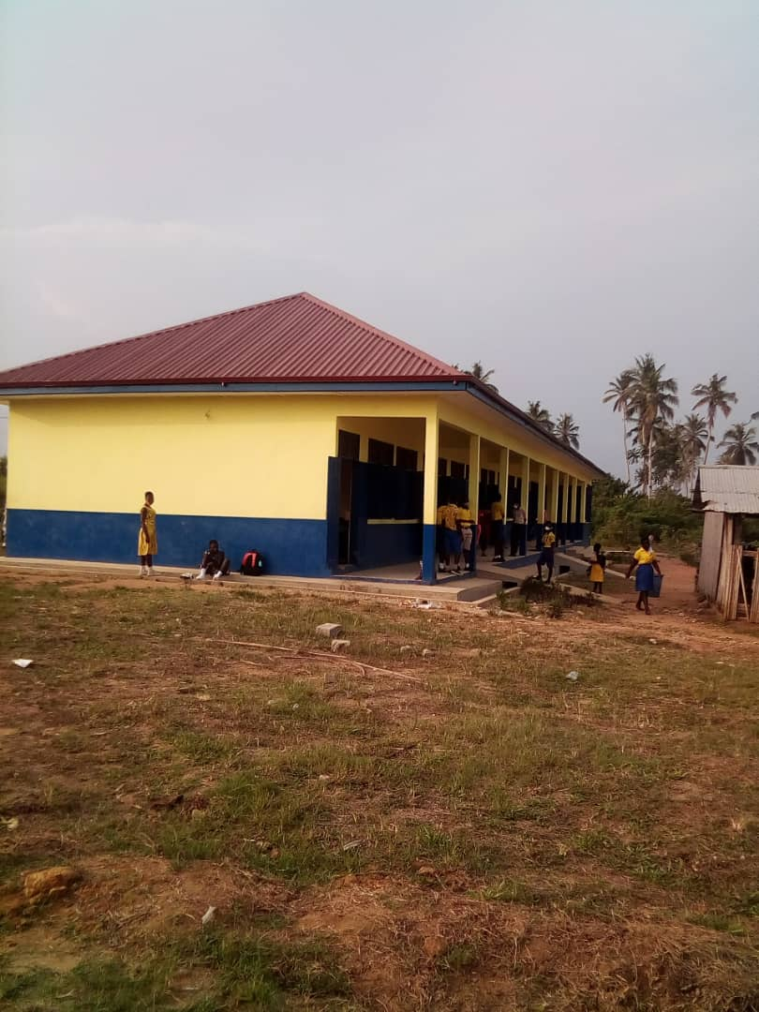

PROJECT: CONSTRUCTION OF 3 UNIT CLASROOM BLOCK WITH OFFICE AND STORE,
STAFF COMMON ROOM AND ICT CENTER
LOCATION: AWIEBO

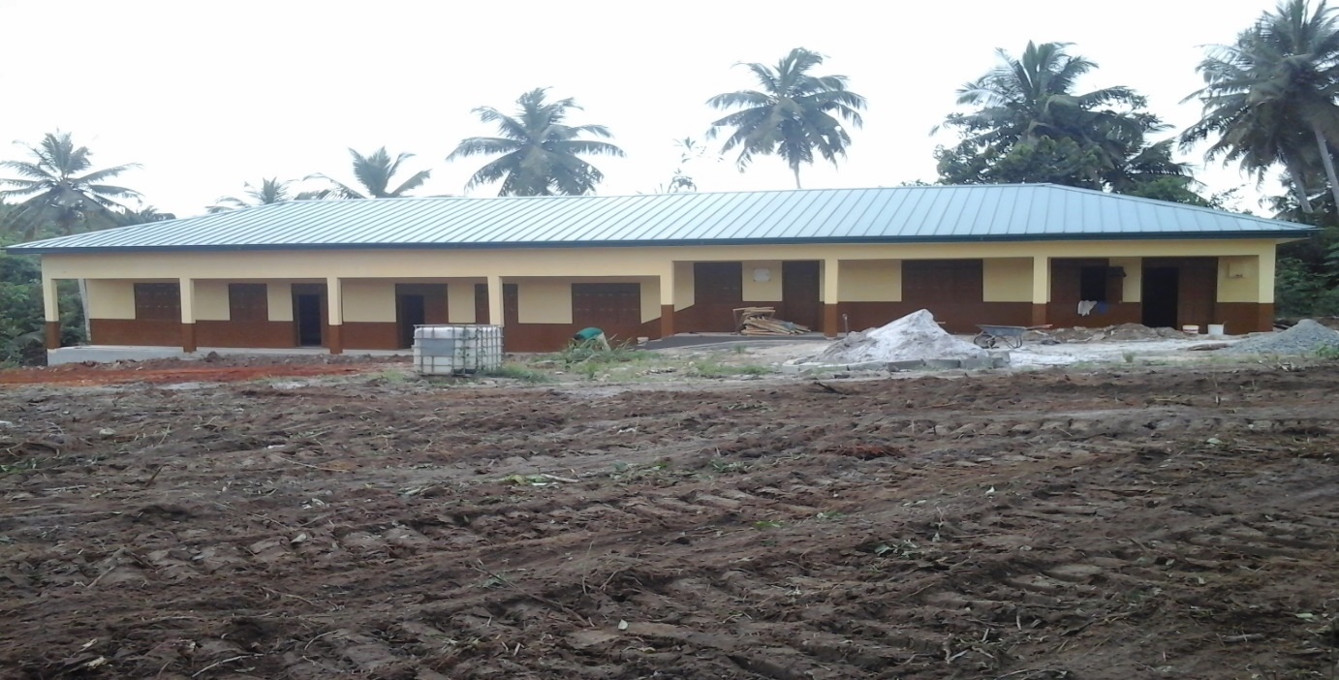

PROJECT: CONSTRUCTION OF 1 NO. 3-UNIT CLASSROOM BLOCK, OFFICE AND
STORE WITH ANCILLARY FACILITIES
LOCATION: AWIAS
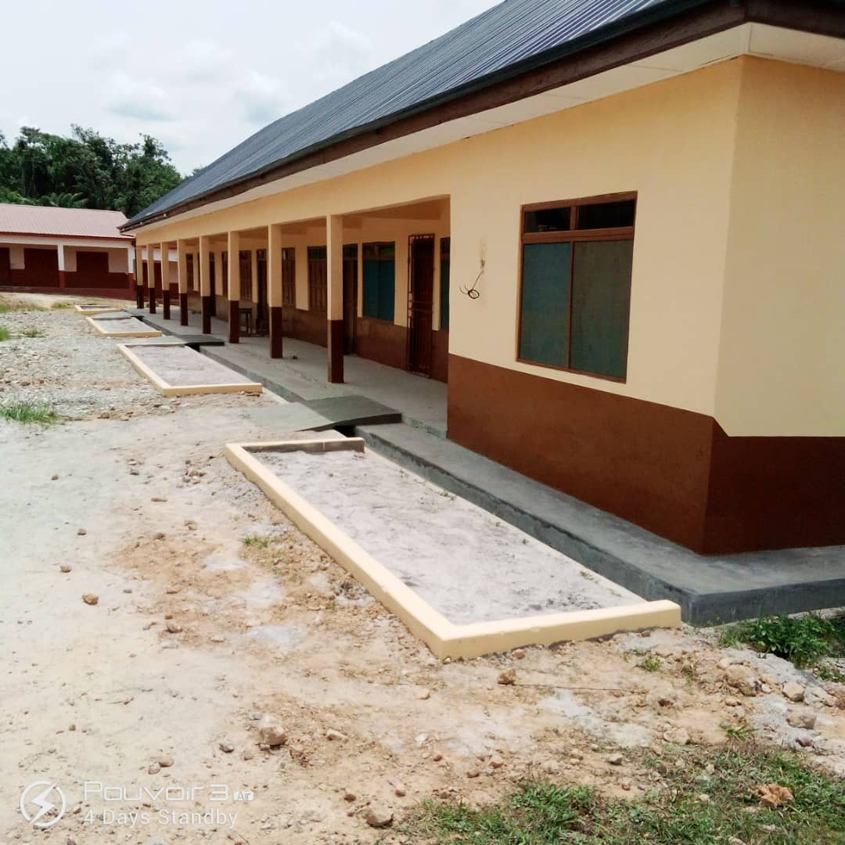

PROJECT: CONSTRUCTION OF 3 UNIT CLASROOM BLOCK WITH OFFICE AND STORE,
STAFF COMMON ROOM AND ICT CENTER
LOCATION: SALMAN

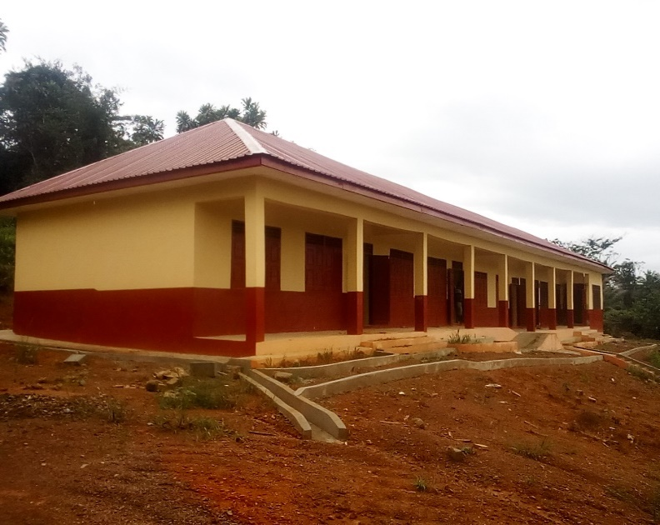
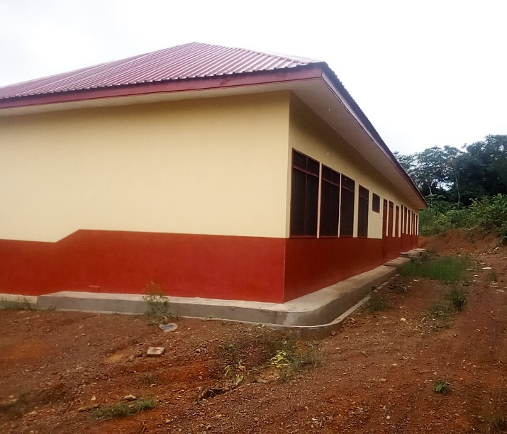

PROJECT: CONSTRUCTION OF 3 UNIT CLASROOM BLOCK WITH OFFICE AND STORE,
STAFF COMMON ROOM AND ICT CENTER
LOCATION: BOMOAKPOLE
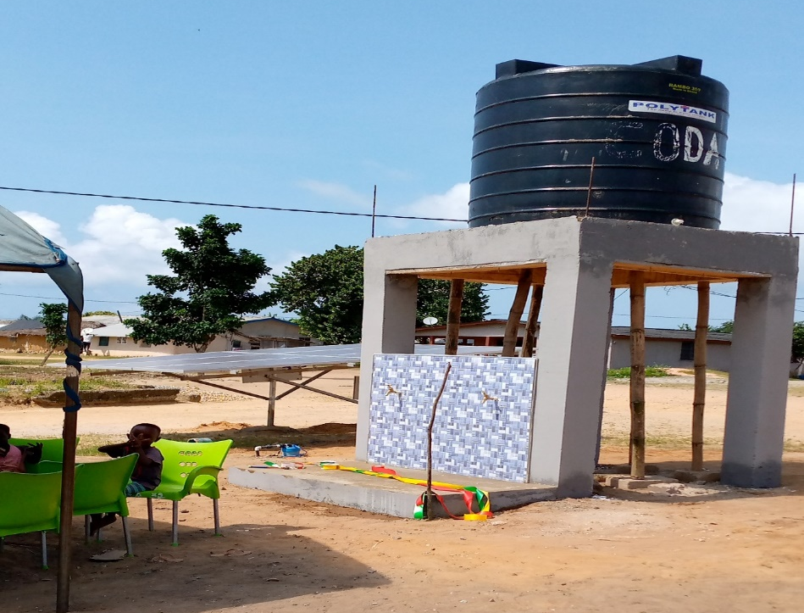

PROJECT: CONSTRUCTION OF 3 NO. SOLAR MECHANIZED BOREHOLE
WITH OVER TANK
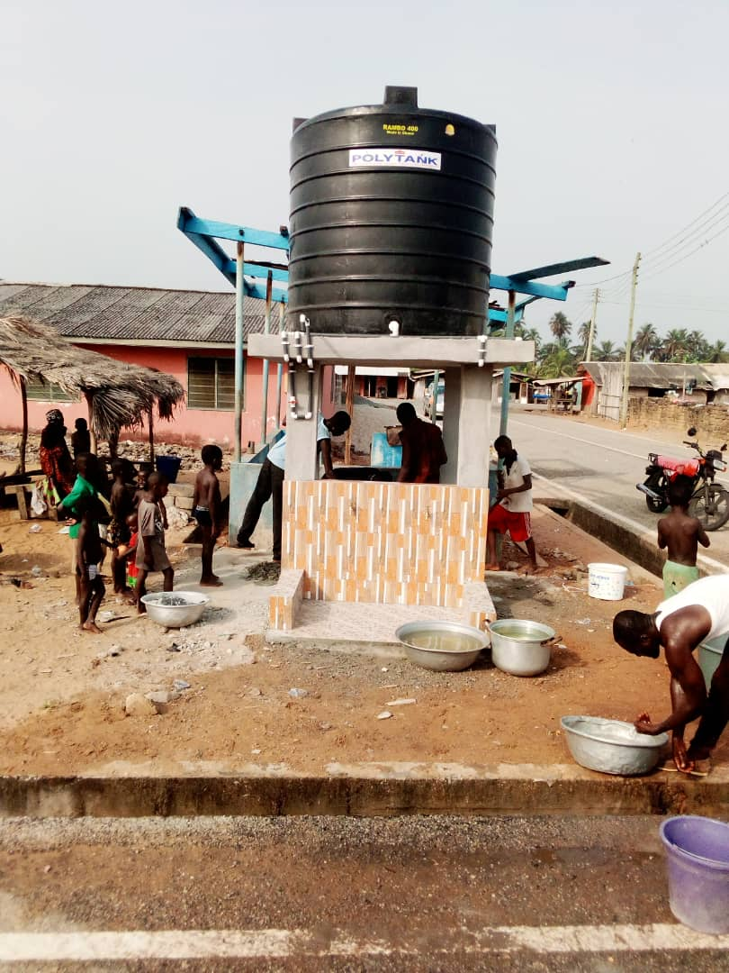
LOCATION: AMPAIN

PROJECT: CONSTRUCTION OF 3 NO. SOLAR MECHANIZED BOREHOLE
WITH OVER TANK
LOCATION: ANKOBRA

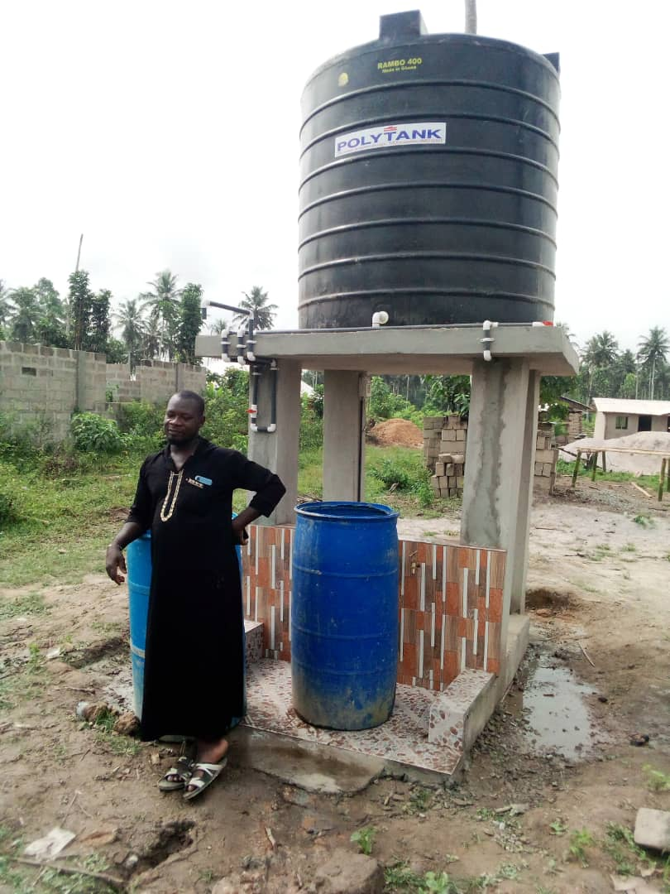

PROJECT: CONSTRUCTION OF 3 NO. SOLAR MECHANIZED BOREHOLE
WITH OVER TANK
LOCATION: A.B BOKAZO

